**Ideation Phase**

**Define the Problem Statements**

|  |  |
| --- | --- |
| Date | 16 June 2025 |
| Team ID | LTVIP2025TMID29152 |
| Project Name | SmartSDLC – AI-Enhanced Software Development Lifecycle |
| Maximum Marks | 2 Marks |

**Customer Problem Statement Template:**

Developers often face delays due to repetitive and manual coding tasks, such as writing boilerplate code, test cases, and debugging. These tasks reduce productivity and increase frustration. SmartSDLC aims to solve these pain points using AI automation.

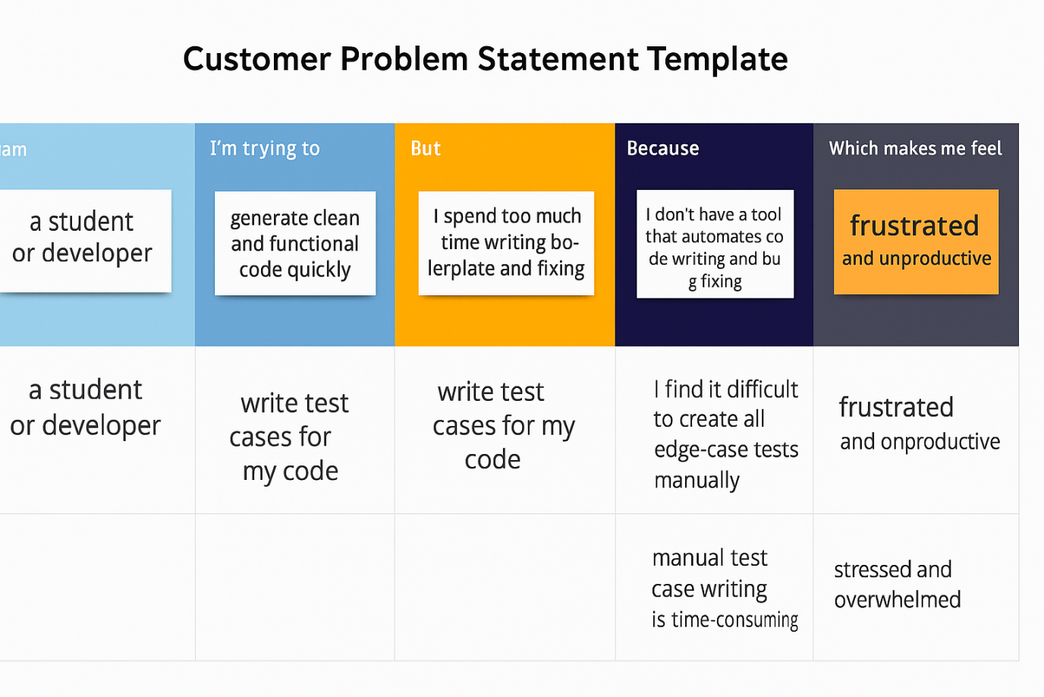

**Problem Statement** :

|  |  |  |  |  |  |
| --- | --- | --- | --- | --- | --- |
| **Problem Statement (PS)** | **I am (Customer)** | **I’m trying to** | **But** | **Because** | **Which makes me feel** |
| PS-1 | a student or developer | generate clean and functional code quickly | I spend too much time writing boilerplate and fixing bugs | I don’t have a tool that automates code writing and bug fixing | frustrated and unproductive |
| PS-2 | a software engineer | write test cases for my code | I find it difficult to create all edge-case tests manually | manual test case writing is time-consuming and error-prone | Stressed and overwhelmed |